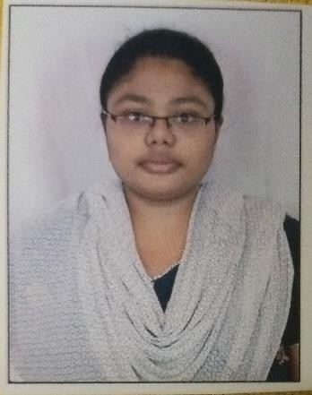
Curriculum Vitae Personal Information

Surname, Given Name: P, Arifa Begum
Date of Birth: 19th January in 2000(Gudur, India) University Degree: Bachelor of Technology (CSE) Marital Status: Single
Contact Information: 4/204-1 Big Mosque Street, Gudur Email: arifabegum.p@gmail.com
Mobile: +91 7337000517

Experience Summary

I served in Financial Services Banking Domain. My project work experience is majorly in the areas of Manual and System Testing. Having 4 years of experience in financial services domain with expertise on Banking Projects (Profile Core Banking System).

Project Detail Summary

Project | India Markets - Trade Finance
Client | BIDV - Myanmar
Organization | Fidelity Information Services India Pvt. Ltd – Bengaluru(IN)
Role | QA - System Tester
Period | May 2025 – Till Date
Responsibilities | - Designed and executed functional and system test cases based on business requirements.  - Performed end to end system testing including regression, integration and UAT support for multiple releases.  - Expertise all screens of the Trade Finance module. (LC, BG, Bills etc.)  - Conducted Sanity and Smoke Testing to ensure application stability and identify critical issues earlier.  - Actively participate in defect triage call with development team for timely resolution.  - Execution of test cases and track the defects in JIRA system.  - Conduct a retest of the resolved bug issues.  - Monitor and track the status of test defects until closed.  - Maintain accurate documentations for executed test programs.

Project | TISCO Xpress Profile - CR
Client | TISCO - Vietnam
Organization | Fidelity Information Services India Pvt. Ltd – Bengaluru(IN)
Role’s Handled | QA – System Tester
Period | NOV 2024 – JAN 2024
Responsibilities | - Participated individual member in SIT testing on the client environment using Soap UI tool.  - Prepared required test data for the CR.  - Create Test Cases and captured evidences for the executed test cases.  - Conducted one round of regression testing to avoid more issues in UAT.

Project | National Bank of Pakistan (v7.6 Upgrade)
Client | NBPUPG – Pakistan
Organization | Fidelity Information Services India Pvt. Ltd – Bengaluru(IN)
Role | QA – System Tester
Period | April 2022 - April 2025
Responsibilities | - Understanding new concepts of the Profile Core Banking System.  - Experienced in Web Based and Window Based Applications (WebCSR, WebAdmin, Profile and Profile Direct Teller)  - Preparation of Test Data, Test Scenarios for the project based on the functional specification document.  - Investigate test problems and implement solutions.  - Conducted regression test to ensure new features or updates do not affect existing functionality.  - Involved in all test phases for the new requirements introduced in the project.
Achievement | - Got On Spot Award for my Contribution towards the project.  - As a member of test support in NBP Team, I’ve been Recognized as the winners of Above & Beyond Q3,2024.

Certifications | - Completed Software Testing Course from Great Learning.  - Completed Python for Data Science and UI from Coursera.  - Completed Python for Data Structures from Coursera.

University Education

2017 – 2021 Bachelor of Technology – Computer Science & Engineering
SVEC Affiliated to JNTU University, Andhra Pradesh, India

technical Skills

Operating System | Software Testing Skills & Tools | Database
Putty | - Manual Testing  - Test Management  - STLC  - JIRA  - Agile  - Soap UI  - Test Rail | SQL

(Arifa Begum P)

